Assessment Schedule – 2014

Chemistry: Demonstrate understanding of the properties of selected organic compounds (91165)
Evidence Statement
Q | Evidence |  |  |  | Achievement |  |  | Achievement with Merit |  |  | Achievement with Excellence
ONE  (a) | 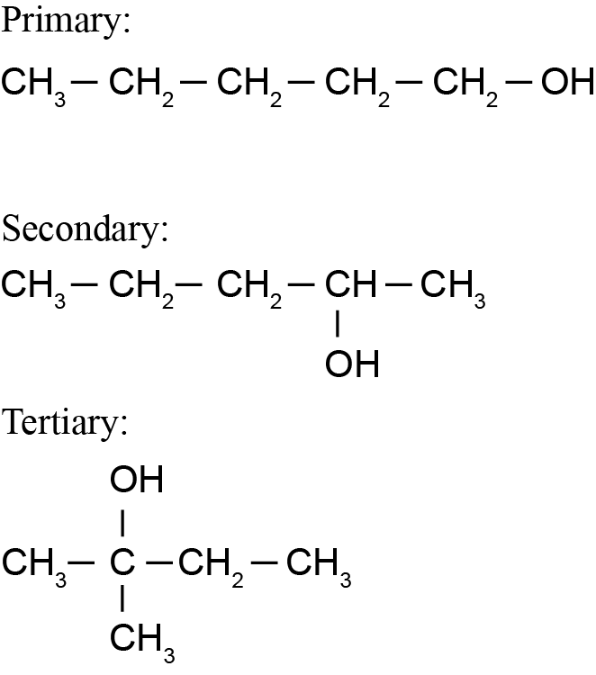 |  |  |  | - Draws TWO alcohols correctly.
(b)(i)  (ii) |  |  |  |  | - Draws the primary alcohol that is oxidised.
(b)(i)  (ii) | 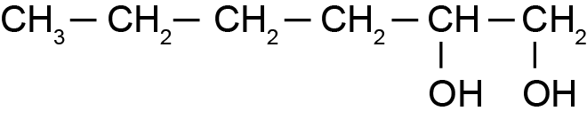 |  |  |  | - Draws the product of the reaction.
(c) | All three reactions are substitution reactions. In all three reactions an atom or group of atoms is being replaced with another atom or group of atoms.  In Reaction One; a Br atom replaces an H atom. UV light is necessary.  In Reaction Two; a Cl atom replaces the OH group. No conditions are required.  In Reaction Three; the Cl atom is replaced by NH₂. No conditions are required.  Two layers form in Reaction One as hexane is non-polar and the product (bromohexane) is effectively also non-polar. The water from the bromine water is polar and therefore the non-polar organic reactant and product will not dissolve in the water; because of this, two layers form as this polar and non-polar layer do not mix. |  |  |  | - States that all reactions are substitution reactions.  - States the condition required for Reaction One.  - States that water or Br₂ (aq) is polar  OR  Some organic compounds are non-polar. |  |  | - Explains substitution reactions in terms of atoms or groups of atoms being replaced.  - Explains why two layers form by linking the following:  - water is polar and the bromohexane / hexane is non-polar  OR  - Polar and non-polar compounds do not dissolve in each other. |  |  | - Compares and contrasts the reactions by fully explaining why all three reactions are substitution reactions with reasons involving the atoms or groups of atoms.  - Explains fully why two layers form by linking the following:  - water is polar and the bromohexane / hexane is non-polar  AND  - Polar and non-polar compounds do not dissolve in each other.
NØ |  | N1 | N2 | A3 |  | A4 | M5 |  | M6 | E7 |  | E8
No response or no relevant evidence |  | 1a | 2a | 3a |  | 5a | 1m |  | 2m | 1e |  | 2e

Question  Two | Evidence |  |  |  | Achievement |  |  | Merit |  |  | Excellence
(a) | 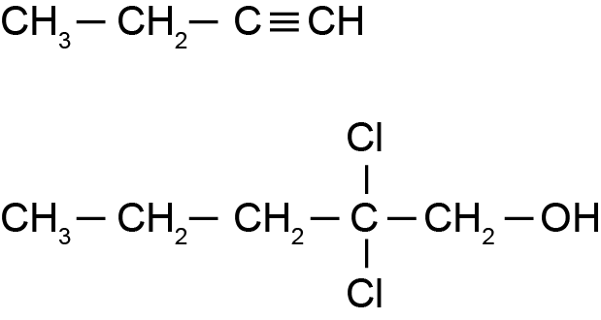  Pentanamine or pentylamine or 1-aminopentane  3-methylhexanoic acid  2,4-dichlorohex-3-ene |  |  |  | - ONE structure .  AND  TWO names correct.
(b) | 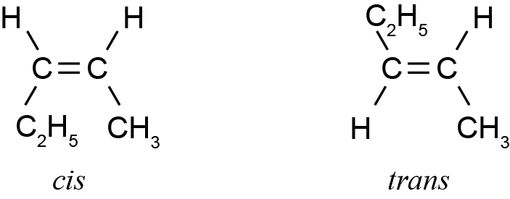  For cis and trans isomers to occur a carbon-carbon double bond must be present as this prevents any rotation about this bond, and the atoms or groups of atoms attached to the two carbon atoms are therefore fixed in position. This means that molecule C cannot have cis and trans isomers as it does not have a double bond.  For compound B one of the carbon atoms in the double bond has two of the same atom attached to it (two H’s). Therefore it cannot have cis and trans isomers because if these two H atoms swapped position it would still be the same molecule.  Therefore only compound A can have cis and trans isomers as it does have a double bond preventing free rotation, and it does not have one of the carbons in the double bond with two of the same atom or groups of atoms attached to it. |  |  |  | - Draws the cis and trans molecules correctly.  - States a double bond required for cis and trans isomerism.  OR  cannot be C as it has no double bond.  - States it cannot be B as one of the carbons in the double bond has 2 of the same atoms attached to it. |  |  | - Explains that a double bond is required to prevent free rotation and therefore it cannot be molecule C as it has no carbon-carbon double bond.  OR  In compound B, one of the carbon atoms in the double bond has two hydrogen atoms attached to it. |  |  | Compares and contrasts the structures by  - Explaining that a carbon – carbon double bond is required to prevent free rotation, and therefore it cannot be molecule C as it has no carbon-carbon double bond.  AND  In compound B one of the carbon atoms in the double bond has two hydrogen atoms attached to it.
(c)(i)  (ii) | 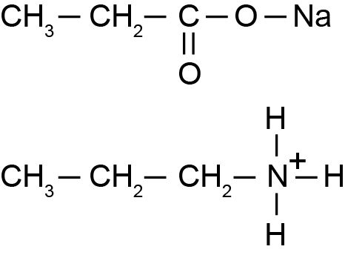  Na |  |  |  | - Has one product correct for either reaction (i) or (ii).
 | When propanoic acid reacts with sodium carbonate, an acid-base reaction occurs in which sodium propanoate, water and carbon dioxide are formed. It is acid-base because the propanoic acid donates a proton, forming the propanoate ion.  When propanamine reacts with HCl or H₂SO₄, acid-base reactions occur. Amines are bases and as a result amines accept protons from acids. In these two reactions both sulfuric acid and hydrochloric acid donate protons to the amine to form organic salts.  When propan-1-ol reacts with HCl, a substitution reaction occurs; in this reaction the Cl from HCl replaces the –OH group from propan-1-ol, forming a haloalkane.  The reaction between conc. H₂SO₄ / heat, and propan-1-ol is an elimination reaction because an –OH group attached to C1, and a hydrogen atom from C2 are both removed from the organic molecule. A double bond forms between C1 & C2, with the elimination of water, forming propene. |  |  |  | - States THREE correct types of reaction.  OR  States a correct type of reaction with a supporting reason. |  |  | - Full explains one of the acid-base reactions.  OR  Identifies AND partially explains TWO different types of reactions. |  |  | Compares and contrasts the reactions by:  - Fully explaining one of the acid- base reactions.  AND  Fully explaining the substitution reaction.  AND  Fully explaining the elimination reaction.
NØ |  | N1 | N2 | A3 |  | A4 | M5 |  | M6 | E7 |  | E8
No response or no relevant evidence |  | 1a | 2a | 3a |  | 5a | 1m |  | 2m | 1e |  | 2e

Question  Three | Evidence |  |  |  | Achievement |  |  | Merit |  |  | Excellence
(a)(i)  (ii) | It is an addition reaction because the double bond is breaking and an H and a Cl are being added to each of the carbons that were in the double bond. |  |  |  | - Recognises that atoms are being added across the double bond. |  |  | - Because the double bond is breaking and an H and a Cl are being added to each of the carbons that were in the double bond.
(a)(i)  (ii) | It is the major product because the hydrogen atom from HCl more often adds onto the carbon atom in the double bond which already contains the most hydrogen atoms; in this case, C1. Therefore the Cl atom from the HCl joins onto the carbon atom in the double bond which had the least number of hydrogen atoms; in this case, C2. |  |  |  | - States Markovnikov's rule. |  |  | - Explains why the major product forms in Reaction 1.
(b)(i)  (ii) | It is an elimination reaction because two atoms are being removed from the molecule and a double bond is being formed between the carbon atoms from which the atoms have been removed. |  |  |  | - Recognises that atoms are being removed in Reaction 2. |  |  | - Explains that two atoms are being removed from the molecule and a double bond is being formed between the carbon atoms from which the atoms have been removed.
(b)(i)  (ii) | 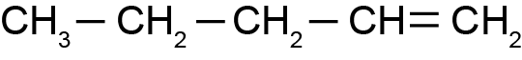 |  |  |  | - Correctly draws the product for Reaction 4.
(c)(i) | 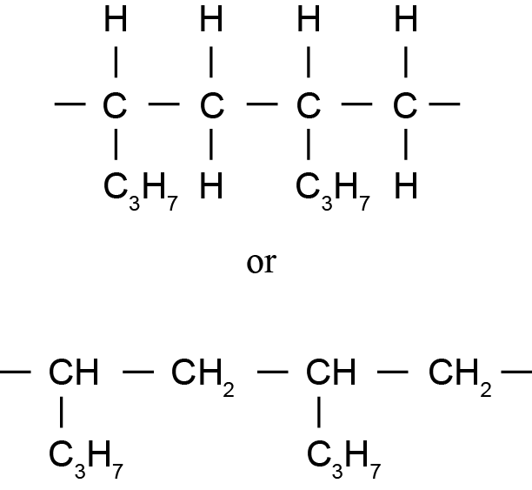 |  |  |  | - Draws TWO repeating units for the polymer formed in Reaction 5. |  |  | .
(ii) | The molecular formulae of the two repeating units of both polymers are the same, but the structural formulae are different.  OR  States repeating units are structural isomers.  Addition polymerisation occurs when the C=C breaks and the carbon atoms in this double bond join to each other from adjacent molecules to form long chains.  In Reaction 3, the polymer formed will have a carbon with one hydrogen and a methyl group, and a carbon with one hydrogen and an ethyl group, as its repeating unit, due to the double bond being on the C2 position.  In Reaction 5, since the double bond is in a different position (the C1 position), the polymer formed will have as its repeating unit a carbon atom with 2 hydrogen atoms attached, and a carbon atom with one hydrogen attached and a propyl group attached. |  |  |  | - Recognises different positions of double bonds within the structures of Reactions 3 & 5.  OR  States that the monomers are structural isomers or something similar. |  |  | - Explains that the double bond located in different positions results in two different polymers |  |  | - Compares and contrasts the two polymers.
NØ |  | N1 | N2 | A3 |  | A4 | M5 |  | M6 | E7 |  | E8
No response or no relevant evidence |  | 1a | 2a | 3a |  | 5a | 3m |  | 4m | 1e  with minor error / omission. |  | 1e

Cut Scores
 | Not Achieved | Achievement | Achievement with Merit | Achievement with Excellence
Score range | 0 – 7 | 8 – 14 | 15 – 18 | 19 – 24

